4

THE MARKET FORCES OF SUPPLY AND DEMAND

WHAT’S NEW IN THE SEVENTH EDITION:

The In the News feature “Price Increases after Disasters” has been updated with a new article.

LEARNING OBJECTIVES:

By the end of this chapter, students should understand:

➢ what a competitive market is.

➢ what determines the demand for a good in a competitive market.

➢ what determines the supply of a good in a competitive market.

➢ how supply and demand together set the price of a good and the quantity sold.

➢ the key role of prices in allocating scarce resources in market economies.

CONTEXT AND PURPOSE:

Chapter 4 is the first chapter in a three-chapter sequence that deals with supply and demand and how markets work. Chapter 4 shows how supply and demand for a good determines both the quantity produced and the price at which the good sells. Chapter 5 will add precision to the discussion of supply and demand by addressing the concept of elasticity—the sensitivity of the quantity supplied and quantity demanded to changes in economic variables. Chapter 6 will address the impact of government policies on prices and quantities in markets.
The purpose of Chapter 4 is to establish the model of supply and demand. The model of supply and demand is the foundation for the discussion for the remainder of this text. For this reason, time spent studying the concepts in this chapter will return benefits to your students throughout their study of economics. Many instructors would argue that this chapter is the most important chapter in the text.

KEY POINTS:

• Economists use the model of supply and demand to analyze competitive markets. In a competitive market, there are many buyers and sellers, each of whom has little or no influence on the market price.

• The demand curve shows how the quantity of a good demanded depends on the price. According to the law of demand, as the price of a good falls, the quantity demanded rises. Therefore, the demand curve slopes downward.

• In addition to price, other determinants of how much consumers want to buy include income, the prices of substitutes and complements, tastes, expectations, and the number of buyers. If one of these factors changes, the demand curve shifts.

• The supply curve shows how the quantity of a good supplied depends on the price. According to the law of supply, as the price of a good rises, the quantity supplied rises. Therefore, the supply curve slopes upward.

• In addition to price, other determinants of how much producers want to sell include input prices, technology, expectations, and the number of sellers. If one of these factors changes, the supply curve shifts.

• The intersection of the supply and demand curves determines the market equilibrium. At the equilibrium price, the quantity demanded equals the quantity supplied.

• The behavior of buyers and sellers naturally drives markets toward their equilibrium. When the market price is above the equilibrium price, there is a surplus of the good, which causes the market price to fall. When the market price is below the equilibrium price, there is a shortage, which causes the market price to rise.

• To analyze how any event influences a market, we use the supply-and-demand diagram to examine how the event affects equilibrium price and quantity. To do this we follow three steps. First, we decide whether the event shifts the supply curve or the demand curve (or both). Second, we decide which direction the curve shifts. Third, we compare the new equilibrium with the initial equilibrium.

• In market economies, prices are the signals that guide economic decisions and thereby allocate scarce resources. For every good in the economy, the price ensures that supply and demand are in balance. The equilibrium price then determines how much of the good buyers choose to consume and how much sellers choose to produce.

CHAPTER OUTLINE:

I. Markets and Competition


You may want to provide students with examples of markets other than the traditional retail store or the stock market. These include the online advertising sites such as eBay and Craigslist, the college “career services” department through which they can look for employment upon graduation, or the market for illegal drugs on a college campus. Be sure to list the good or service being sold, the buyers, and the sellers in each example.

A. What Is a Market?

1. Definition of market: a group of buyers and sellers of a particular good or service.

2. Markets can take many forms and may be organized (agricultural commodities) or less organized (ice cream

B. What Is Competition?

1. Definition of competitive market: a market in which there are so many buyers and so many sellers that each has a negligible impact on the market price.

2. Each buyer knows that there are several sellers from which to choose. Sellers know that each buyer purchases only a small amount of the total amount sold.


Students may find the name for this type of market misleading. You will have to point out that firms in a competitive market do not face head-to-head rivalry as in sports competitions.

C. In this chapter, we will assume that markets are perfectly competitive.

1. Characteristics of a perfectly competitive market:

a. The goods being offered for sale are exactly the same.

b. The buyers and sellers are so numerous that no single buyer or seller has any influence over the market price.

2. Because buyers and sellers must accept the market price as given, they are often called "price takers."

3. Not all goods are sold in a perfectly competitive market.

a. A market with only one seller is called a monopoly market.

b. Other markets fall between perfect competition and monopoly.

D. We will start by studying perfect competition.

1. Perfectly competitive markets are the easiest to analyze because buyers and sellers take the price as a given.

2. Because some degree of competition is present in most markets, many of the lessons that we learn by studying supply and demand under perfect competition apply in more complicated markets.

II. Demand

A. The Demand Curve: The Relationship between Price and Quantity Demanded

1. Definition of quantity demanded: the amount of a good that buyers are willing and able to purchase.

2. One important determinant of quantity demanded is the price of the product.

a. Quantity demanded is negatively related to price. This implies that the demand curve is downward sloping.

Make sure that you explain that, when we discuss the relationship between quantity demanded and price, we hold all other variables constant. You will need to emphasize this more than once to ensure that students understand why a change in price leads to a movement along the demand curve.

b. Definition of law of demand: the claim that, other things being equal, the quantity demanded of a good falls when the price of the good rises.

3. Definition of demand schedule: a table that shows the relationship between the price of a good and the quantity demanded.

Figure 1

Price of Ice-Cream Cone | Quantity of Cones Demanded | 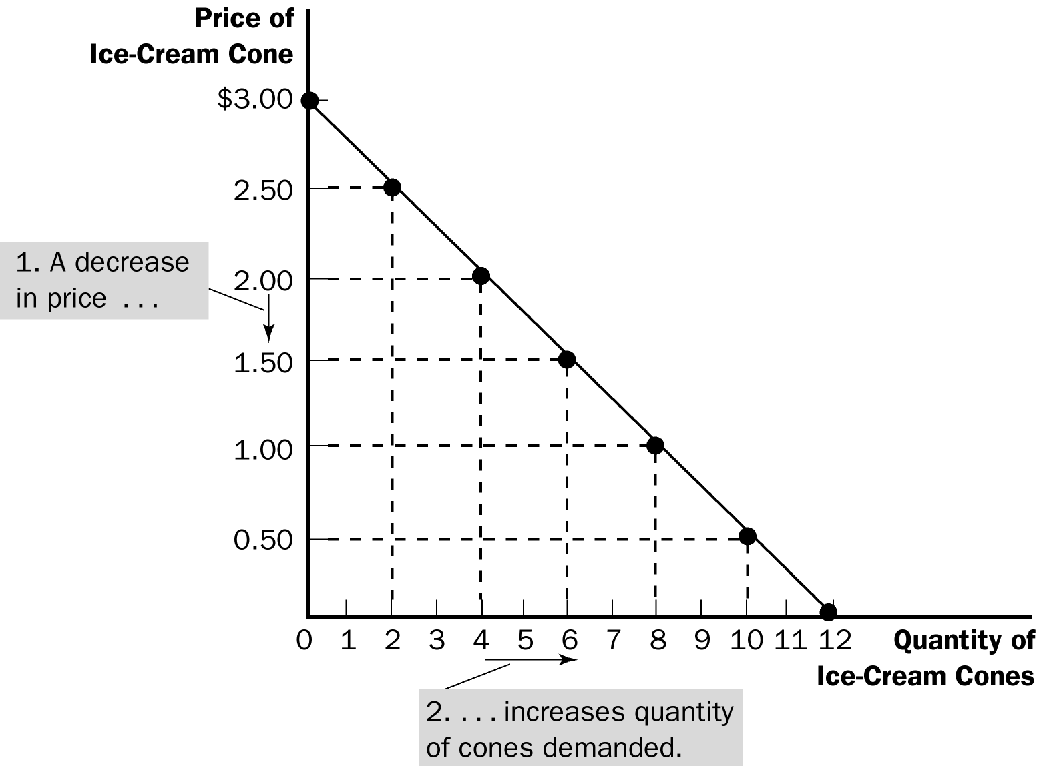
$0.00 | 12
$0.50 | 10
$1.00 | 8
$1.50 | 6
$2.00 | 4
$2.50 | 2
$3.00 | 0

When you draw the demand curve for the first time, take the time to plot each of the points from the demand schedule. This way, students who have difficulty with graphs can see the relationship between the demand schedule and the demand curve. This is a good opportunity to see if students understand the (x, y) coordinate system.

4. Definition of demand curve: a graph of the relationship between the price of a good and the quantity demanded.

a. Price is generally drawn on the vertical axis.

b. Quantity demanded is represented on the horizontal axis.

ALTERNATIVE CLASSROOM EXAMPLE:
Here is a demand schedule for ink pens:

Price ($) | Quantity Demanded
.05 | 1000
.10 | 800
.15 | 600
.20 | 400
.25 | 200

B. Market Demand versus Individual Demand

1. The market demand is the sum of all of the individual demands for a particular good or service.

2. The demand curves are summed horizontally—meaning that the quantities demanded are added up for each level of price.

Figure 2

3. The market demand curve shows how the total quantity demanded of a good varies with the price of the good, holding constant all other factors that affect how much consumers want to buy.

C. Shifts in the Demand Curve

Students have a difficult time understanding the difference between a change in price (which causes a movement along the demand curve) and a change in another determinant (which shifts the demand curve). You will have to emphasize what is meant by “change in quantity demanded” and “change in demand” several times using different examples. The Case Study on smoking will help to explain this difference as well.

1. Because the market demand curve holds other things constant, it need not be stable over time.

Figure 3

2. If any of these other factors change, the demand curve will shift.

a. An increase in demand is represented by a shift of the demand curve to the right.

b. A decrease in demand is represented by a shift of the demand curve to the left.

3. Income

a. The relationship between income and quantity demanded depends on what type of good the product is.

b. Definition of normal good: a good for which, other things equal, an increase in income leads to an increase in demand.

c. Definition of inferior good: a good for which, other things equal, an increase in income leads to a decrease in demand.

Be careful! Students often confuse inferior goods with what economists call “bads.” One way to differentiate them is to ask students whether they would ever be willing to pay for such things as pollution or garbage.

4. Prices of Related Goods

a. Definition of substitutes: two goods for which an increase in the price of one good leads to an increase in the demand for the other.

b. Definition of complements: two goods for which an increase in the price of one good leads to a decrease in the demand for the other.

5. Tastes

6. Expectations

a. Future income

b. Future prices

7. Number of Buyers

Table 1

It would be a good idea to work through an example changing each of these variables individually. Students will benefit from the discussion and the practice drawing graphs.

D. Case Study: Two Ways to Reduce the Quantity of Smoking Demanded

Figure 4

1. Public service announcements, mandatory health warnings on cigarette packages, and the prohibition of cigarette advertising on television are policies designed to reduce the demand for cigarettes (and shift the demand curve to the left).

2. Raising the price of cigarettes (through tobacco taxes) lowers the quantity of cigarettes demanded.

a. The demand curve does not shift in this case, however.

b. An increase in the price of cigarettes can be shown by a movement along the original demand curve.

3. Studies have shown that a 10% increase in the price of cigarettes causes a 4% reduction in the quantity of cigarettes demanded. For teens, a 10% increase in price leads to a 12% drop in quantity demanded.

4. Studies have also shown that a decrease in the price of cigarettes is associated with greater use of marijuana. Thus, it appears that tobacco and marijuana are complements.

III. Supply

If you have taken enough time teaching demand, students will catch on to supply more quickly. However, remember that as consumers, students can understand demand decisions more easily than supply decisions. You may want to point out to them that they are suppliers (of their time and effort) in the labor market.

A. The Supply Curve: The Relationship between Price and Quantity Supplied

1. Definition of quantity supplied: the amount of a good that sellers are willing and able to sell.

a. Quantity supplied is positively related to price. This implies that the supply curve will be upward sloping.

b. Definition of law of supply: the claim that, other things equal, the quantity supplied of a good rises when the price of the good rises.

Again you will want to point out that everything else is held constant when we discuss the relationship between price and quantity supplied. Students should understand that a change in price causes a movement along the supply curve.

2. Definition of supply schedule: a table that shows the relationship between the price of a good and the quantity supplied.

3. Definition of supply curve: a graph of the relationship between the price of a good and the quantity supplied.

Figure 5

Price of Ice-Cream Cone | Quantity of Cones Supplied | 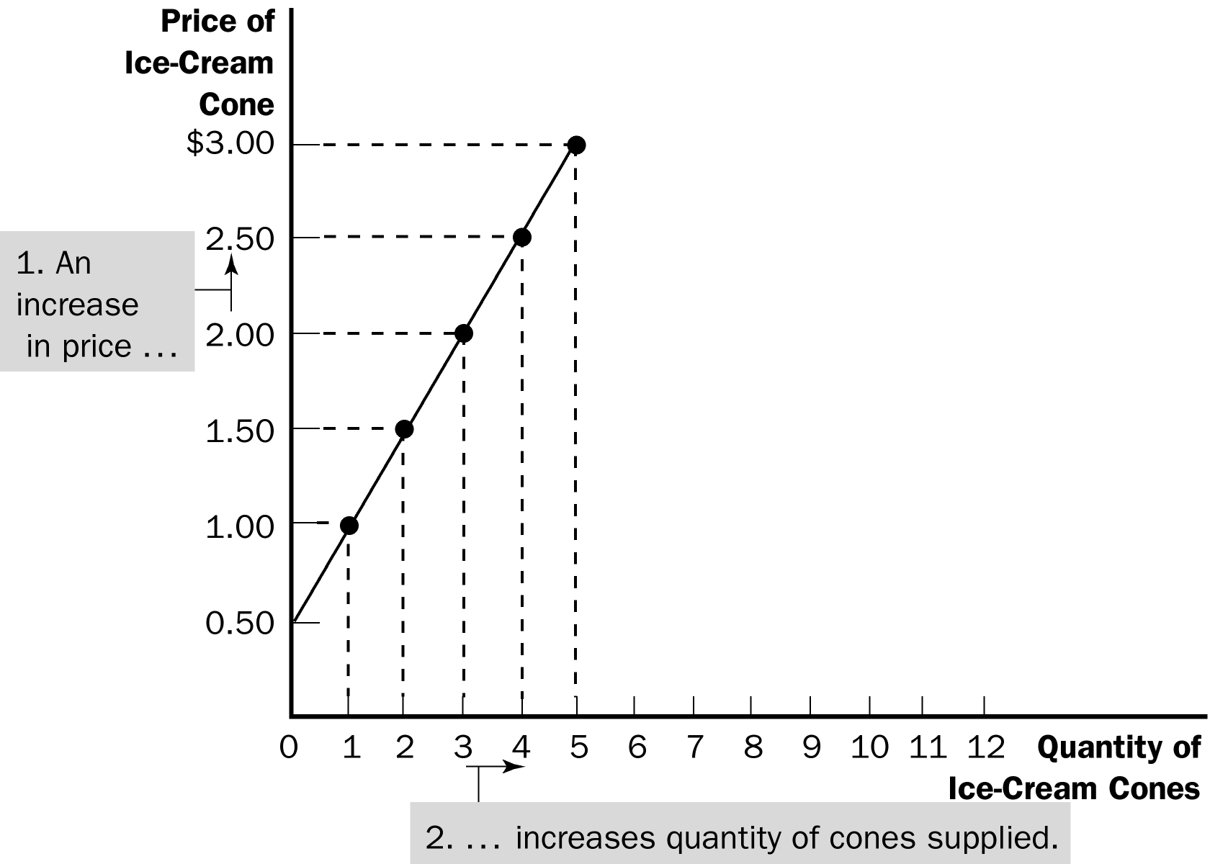
$0.00 | 0
$0.50 | 0
$1.00 | 1
$1.50 | 2
$2.00 | 3
$2.50 | 4
$3.00 | 5

B. Market Supply versus Individual Supply

Figure 6

1. The market supply curve can be found by summing individual supply curves.

2. Individual supply curves are summed horizontally at every price.

3. The market supply curve shows how the total quantity supplied varies as the price of the good varies.

C. Shifts in the Supply Curve

Figure 7

1. Because the market supply curve holds other things constant, the supply curve will shift if any of these factors changes.

a. An increase in supply is represented by a shift of the supply curve to the right.

b. A decrease in supply is represented by a shift of the supply curve to the left.

You will want to take time to emphasize the difference between a “change in supply” and a “change in quantity supplied.”

2. Input Prices

3. Technology

4. Expectations

5. Number of Sellers

Table 2

IV. Supply and Demand Together

A. Equilibrium

1. The point where the supply and demand curves intersect is called the market’s equilibrium.

2. Definition of equilibrium: a situation in which the market price has reached the level at which quantity supplied equals quantity demanded.

3. Definition of equilibrium price: the price that balances quantity supplied and quantity demanded.

Students will benefit from seeing equilibrium using both a graph and a supply-and-demand schedule. The schedule will also make it easier for students to understand concepts such as shortages and surpluses.

4. The equilibrium price is often called the "market-clearing" price because both buyers and sellers are satisfied at this price.

Figure 8

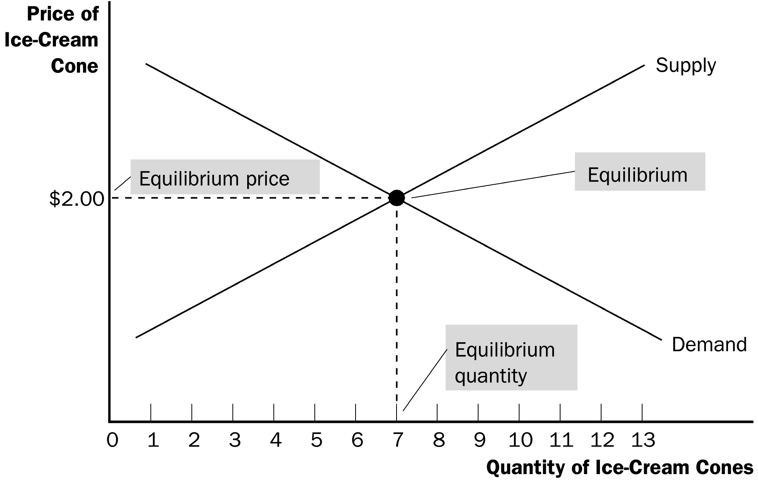

5. Definition of equilibrium quantity: the quantity supplied and the quantity demanded at the equilibrium price.

Activity 1—A Market Example

Type: In-class demonstration
Topics: Individual demand, market demand, equilibrium price, allocation
Materials needed: A bag of Pepperidge Farm cookies (15 cookies), 5 volunteers
Time: 35 minutes
Class limitations: Works in large lectures or small classes with over 15 students

Purpose
This is an example of a real-world market, where real goods are exchanged for real money. It is a free market, so there will be no coercion, but participants should think carefully about their answers because actual trades will take place.

Instructions
Ask five volunteers to participate in a market for Pepperidge Farm cookies. Read some of the package copy describing these “distinctively delicious” cookies. Write each volunteer’s name on the board.

Ask the volunteers how many cookies they would be willing to buy at various prices. Record these prices and quantities. Give the volunteers the opportunity to revise their numbers if the figures do not accurately reflect their willingness to pay. Remind them this isn’t a hypothetical exercise and they will have to pay real money.

At this point, there will be five individual demand curves, which can be graphed if desired.

Add the individual quantities at each price to find the market demand at that price. This overall demand is used to find the market equilibrium. Sketch a graph of the market demand.

Supply, in this case, is fixed at the number of cookies in the bag. There are 15 cookies. No more can be produced, and any leftovers will spoil. This gives a vertical supply curve in the very short run at Q = 15. (Sketch the supply curve.)

Try various prices until the individual quantities sum to 15. This will give the equilibrium price and quantity.

Distribute the cookies and collect money from each participant.

Points for Discussion
The demand curves display the typical inverse relation between price and quantity. (Remark on any unusual patterns.) These tell us about each individual’s willingness to pay and reveal information about the marginal benefits of additional cookies to each consumer.

Market demand is aggregated from individual demand curves.

Notice the consumers do not get an equal number of cookies. This is typical of markets, because tastes and incomes vary across individuals.

6. If the actual market price is higher than the equilibrium price, there will be a surplus of the good.

Figure 9
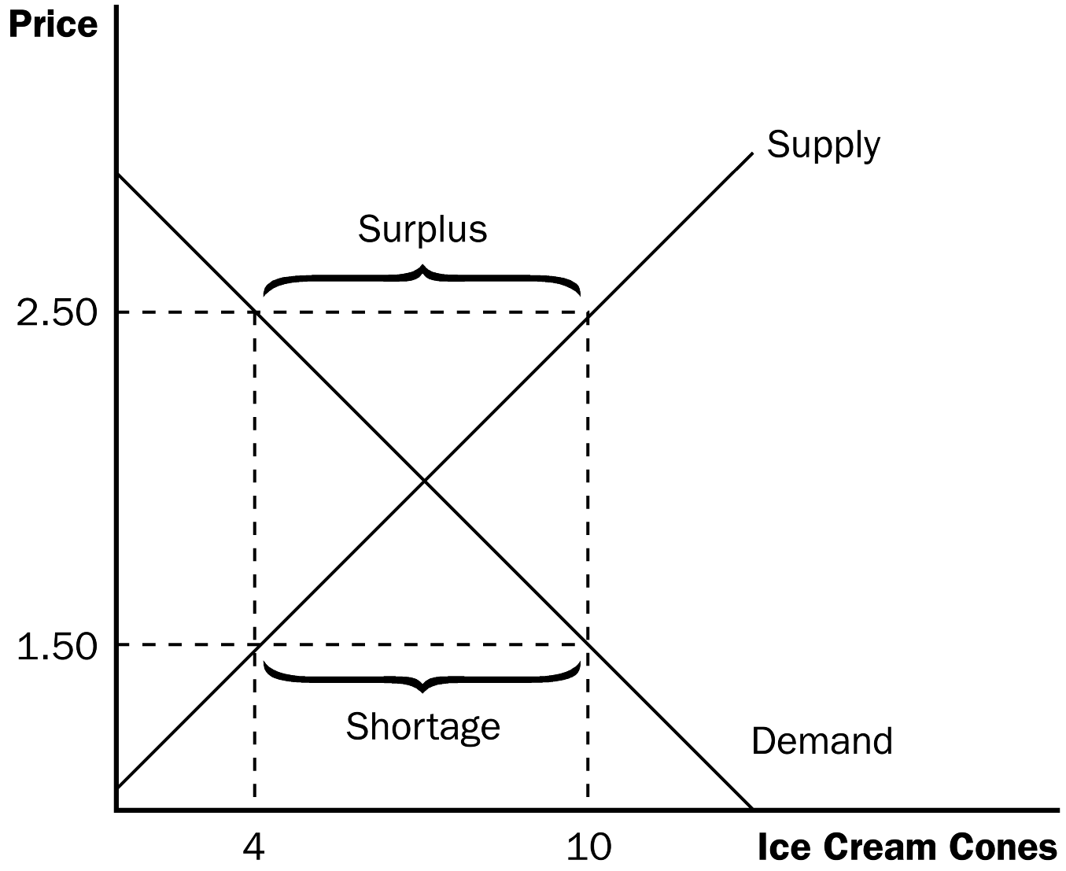

a. Definition of surplus: a situation in which quantity supplied is greater than quantity demanded.

b. To eliminate the surplus, producers will lower the price until the market reaches equilibrium.

7. If the actual price is lower than the equilibrium price, there will be a shortage of the good.

a. Definition of shortage: a situation in which quantity demanded is greater than quantity supplied.

b. Sellers will respond to the shortage by raising the price of the good until the market reaches equilibrium.

8. Definition of the law of supply and demand: the claim that the price of any good adjusts to bring the supply and demand for that good into balance.

Activity 2—Campus Parking

Type: In-class assignment
Topics: Demand, supply, disequilibrium, shortage, rationing
Materials needed: A shortage of student parking on campus
Time: 35 minutes
Class limitations: Works in large lectures or small classes, if there is a campus parking problem.

Purpose
Nothing seems to generate more heated discussion than campus parking. If your school has a parking shortage this assignment brings the ideas of price rationing and resource allocation to an issue close to the students’ hearts.

A. K. Sen’s parable of the bamboo flute is a good introduction to this assignment: An artist makes a beautiful instrument that becomes famous throughout the country. A number of claimants arise, each of whom argues that they deserve the flute: the artist who created it, the most talented musician, the poorest musician, the neediest citizen, the hardest working musician, etc. Who deserves the flute? Students will have different opinions on who is most deserving but many will accept a market solution—the person who is willing to pay the most (who has the highest marginal benefit, given the existing distribution of wealth and income). The allocation of campus parking spots makes a nice parallel.

Instruction
Ask the class to answer the following questions. Give them time to write an answer to a question, then discuss their answers before moving to the next question.

Common Answers and Points for Discussion
1. Write down three things that are true about the parking situation on campus.
2. What two problems do you think are most important?

The parking problem has two components in the eyes of most students. Parking permits are too expensive and there are too few spaces.

3. What policies could the administration make to resolve these problems?

Students have many policies to alleviate the situation. The most common suggestion is to ban parking for freshmen. Freshmen respond with lists of other groups who should be banned. Another popular policy would be to open faculty lots to student parking. Parking fees should be lowered or better yet eliminated. Parking violations should have lower fines. More lots should be built. Shuttles, moving sidewalks, and monorails should be installed.

Students never suggest raising prices to reach a market solution.

4. Who needs parking the most?
5. Who would pay the most for parking?

Asking about need and willingness to pay moves the discussion away from group prohibitions; freshmen may be just as needy and equally able to pay.

6. Use a supply-and-demand graph to analyze this problem.

Many students initially have difficulty graphing this problem. They want to illustrate that permit prices are too high, but then their graph will not show the shortage. Eventually they can be convinced that parking, while expensive, is actually priced too low.

7. How would your policy proposals affect the market for parking?

Analysis of the various proposals in a supply-and-demand framework shows some popular policies, like free permits, would aggravate the parking shortage. Policies to restrict demand can reduce the shortage, although there will be inefficiencies in the resulting allocation. Make sure that students realize that building more parking lots is not a shift in the supply curve, but a movement along the existing supply curve. The additional costs of new parking need to be covered by some means: higher parking fees, tuition increases, or taxpayer subsidies.

B. Three Steps to Analyzing Changes in Equilibrium

Table 3

1. Decide whether the event shifts the supply or demand curve (or perhaps both).

2. Determine the direction in which the curve shifts.

3. Use the supply-and-demand diagram to see how the shift changes the equilibrium price and quantity.

This three-step process is very important. Students often want to jump to the end without thinking the change through. They should be provided with numerous examples so that they can see the benefit of analyzing a change in equilibrium one step at a time.

C. Example: A change in market equilibrium due to a shift in demand—the effect of hot weather on the market for ice cream.

Figure 10

Go through changes in supply and demand carefully. Show students why the equilibrium price must change after one of the curves shifts. For example, point out that if demand rises, a shortage will occur at the original equilibrium price. This leads to an increase in price, which causes quantity supplied to rise and quantity demanded to fall until equilibrium is achieved. The end result is an increase in both the equilibrium price and equilibrium quantity. Also point out that an increase in demand leads to an increase in quantity supplied, not supply.

ALTERNATIVE CLASSROOM EXAMPLE:
Go through these examples of events that would shift either the demand or supply of #2 lead pencils:
▪ an increase in the income of consumers
▪ an increase in the use of standardized exams (using opscan forms)
▪ a decrease in the price of graphite (used in the production of pencils)
▪ a decrease in the price of ink pens
▪ the start of a school year
▪ new technology that lowers the cost of producing pencils.

D. Shifts in Curves versus Movements along Curves

1. A shift in the demand curve is called a "change in demand." A shift in the supply curve is called a "change in supply."

Emphasize that students should not think about the curves shifting “up” and “down” but rather think about the curves shifting “right” and “left” (or “out” and “in”). Point out that an increase in demand (or supply) is an increase in the quantity demanded (supplied) at every price. Thus, it is quantity that is getting larger. Review the same principle with a decrease in demand (or supply).

2. A movement along a fixed demand curve is called a "change in quantity demanded." A movement along a fixed supply curve is called a "change in quantity supplied."

It would helpful to students if you draw all four graphs (increase in demand, decrease in demand, increase in supply, and decrease in supply) on the board at the same time. Students will be able to see that the end result of each of these four shifts is unique. Point out to students that they can use these graphs to explain events going on in markets around them. For example, point out changes in gasoline prices seen during the past several years. Then ask students what could have led to these changes in price. Make sure that they realize that they would need to know the effect on equilibrium quantity to determine the ultimate cause.

E. Example: A change in market equilibrium due to a shift in supply—the effect of a hurricane that destroys part of the sugar-cane crop and drives up the price of sugar.

Figure 11

F. Example: Shifts in both supply and demand—the effect of hot weather and a hurricane that destroys part of the sugar cane crop.

Figure 12

G. Summary

1. When an event shifts the supply or demand curve, we can examine the effects on the equilibrium price and quantity.

2. Table 4 reports the end results of these shifts in supply and demand.

Table 4

H. In the News: Price Increases after Disasters

1. When a disaster strikes a region, many good experience an increase in demand or a decrease in supply resulting in upward pressure on prices.

2. This article from CNBC.com defends price increases following natural disasters as a natural result of market interactions.

Make sure that you explain to students that two possible outcomes might result, depending on the relative sizes of the shifts in the demand and supply curves. Thus, if they do not know the relative sizes of these shifts, the end effect on either equilibrium price or equilibrium quantity will be ambiguous. Teach students to shift each curve using the three-step method and to draw them on separate graphs.

V. Conclusion: How Prices Allocate Resources

A. The model of supply and demand is a powerful tool for analyzing markets.

B. Supply and demand together determine the prices of the economy’s goods and services.

1. These prices serve as signals that guide the allocation of scarce resources in the economy.

2. Prices determine who produces each good and how much of each good is produced.

Make a big deal about how well prices serve to allocate resources to their highest valued uses. For example, suppose that consumers develop an increased taste for corn and corn products. This leads to an increase in the demand for corn, pushing the price up. This increased price provides incentives to producers to produce more corn. Thus, price signals our wants and desires. This is one reason why markets generally serve as the best way to organize economic activity.

Activity 3—Supply and Demand Article
Type: Take-home assignment
Topics: Shifts in supply or demand, changing equilibrium
Class limitations: Works in any class

Purpose
This assignment is an excellent way to determine which students need extra help in understanding supply and demand. Students who have difficulty with it often need remedial help. Allowing students to correct errors and then resubmit the assignment can be worthwhile because it is fundamental to their understanding of how markets work.

Instructions
Give the students the following assignment:

Find an article in a recent newspaper or magazine illustrating a change in price or quantity in some market. Analyze the situation using economic reasoning.

1. Has there been an increase or decrease in demand? Factors that could shift the demand curve include changes in preferences, changes in income, changes in the price of substitutes or complements, or changes in the number of consumers in the market.
2. Has there been an increase or decrease in supply? Factors that could shift the supply curve include changes in costs of materials, wages, or other inputs; changes in technology; or changes in the number of firms in the market.
3. Draw a supply-and-demand graph to explain this change. Be sure to label your graph and clearly indicate which curve shifts.

Ask students to turn in a copy of the article along with their explanation. Warn students to avoid advertisements because they contain little information. They should be wary of commodity and financial markets unless they have a good understanding of the particular market. Markets for ordinary goods and services are most easily analyzed.

Points for Discussion
Most changes will only shift one curve—either supply or demand—not both. Remind students that price changes will not cause either curve to shift. (But shifting either curve will change price.)

Equilibrium points are not fixed. They change when supply or demand changes. Prices will not necessarily return to previous levels nor will quantities.

Remind the students of the four graphs showing the shifts in supply and demand.

SOLUTIONS TO TEXT PROBLEMS:

Quick Quizzes

1. A market is a group of buyers (who determine demand) and a group of sellers (who determine supply) of a particular good or service. A perfectly competitive market is one in which there are many buyers and many sellers of an identical product so that each has a negligible impact on the market price.

2. Here is an example of a monthly demand schedule for pizza:

Price of Pizza Slice | Number of Pizza Slices Demanded
$ 0.00 | 10
0.25 | 9
0.50 | 8
0.75 | 7
1.00 | 6
1.25 | 5
1.50 | 4
1.75 | 3
2.00 | 2
2.25 | 1
2.50 | 0

The demand curve is graphed in Figure 1.

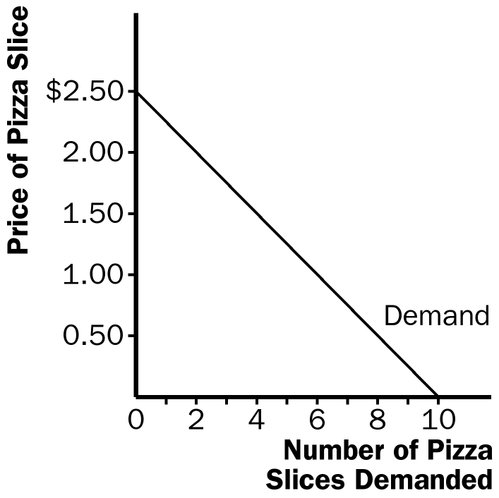

Figure 1

Examples of things that would shift the demand curve include changes in income, prices of related goods like soda or hot dogs, tastes, expectations about future income or prices, and the number of buyers.

A change in the price of pizza would not shift this demand curve; it would only lead to a movement from one point to another along the same demand curve.

3. Here is an example of a monthly supply schedule for pizza:

Price of Pizza Slice | Number of Pizza Slices Supplied
$ 0.00 | 0
0.25 | 100
0.50 | 200
0.75 | 300
1.00 | 400
1.25 | 500
1.50 | 600
1.75 | 700
2.00 | 800
2.25 | 900
2.50 | 1000

The supply curve is graphed in Figure 2.

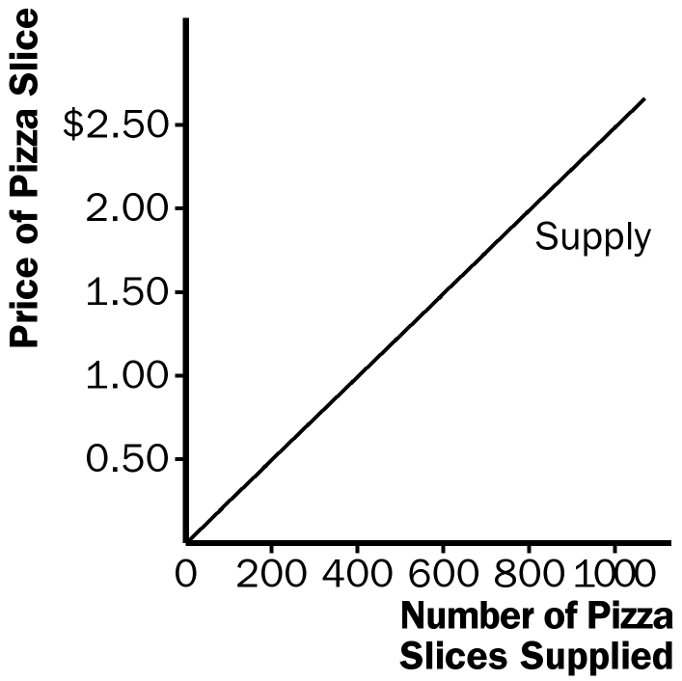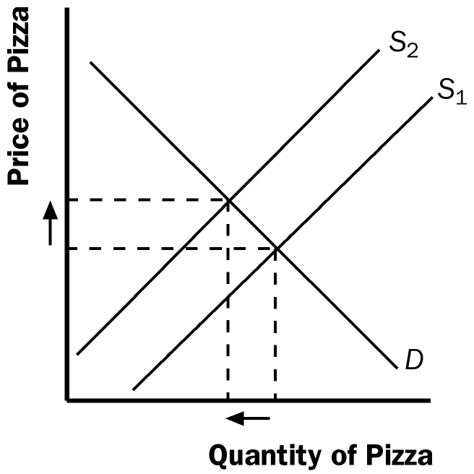

Figure 2 Figure 3

Examples of things that would shift the supply curve include changes in prices of inputs like tomato sauce and cheese, changes in technology like more efficient pizza ovens or automatic dough makers, changes in expectations about the future price of pizza, or a change in the number of sellers.

A change in the price of pizza would not shift this supply curve; it would only lead to a movement from one point to another along the same supply curve.

4. If the price of tomatoes rises, the supply curve for pizza shifts to the left because there has been an increase in the price of an input into pizza production, but there is no shift in demand. The shift to the left of the supply curve causes the equilibrium price to rise and the equilibrium quantity to decline, as Figure 3 shows.

If the price of hamburgers falls, the demand curve for pizza shifts to the left because the lower price of hamburgers will lead consumers to buy more hamburgers and fewer pizzas, but there is no shift in supply. The shift to the left of the demand curve causes the equilibrium price to fall and the equilibrium quantity to decline, as Figure 4 shows.

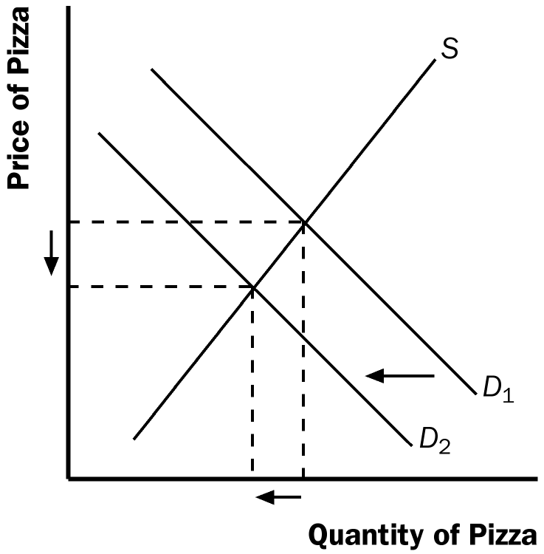

Figure 4

Questions for Review

1. A competitive market is a market in which there are many buyers and many sellers of an identical product so that each has a negligible impact on the market price. Another type of market is a monopoly, in which there is only one seller. There are also other markets that fall between perfect competition and monopoly.

2. The demand schedule is a table that shows the relationship between the price of a good and the quantity demanded. The demand curve is the downward-sloping line relating price and quantity demanded. The demand schedule and demand curve are related because the demand curve is simply a graph showing the points in the demand schedule.

The demand curve slopes downward because of the law of demand—other things being equal, when the price of a good rises, the quantity demanded of the good falls. People buy less of a good when its price rises, both because they cannot afford to buy as much and because they switch to purchasing other goods.

3. A change in consumers' tastes leads to a shift of the demand curve. If the change in consumers' tastes leads to an increase in demand, consumers want to buy more of this good at every price level. A change in price leads to a movement along the demand curve. Because price is measured on the vertical axis, a change in the price represents a movement along the demand curve.

4. Because Popeye buys more spinach when his income falls, spinach is an inferior good for him. His demand curve for spinach shifts out to the right as a result of the decrease in his income.

5. A supply schedule is a table showing the relationship between the price of a good and the quantity a producer is willing and able to supply. The supply curve is the upward-sloping line relating price and quantity supplied. The supply schedule and the supply curve are related because the supply curve is simply a graph showing the points in the supply schedule.

The supply curve slopes upward because when the price is high, suppliers' profits increase, so they supply more output to the market. The result is the law of supply—other things being equal, when the price of a good rises, the quantity supplied of the good also rises.

6. A change in producers' technology leads to a shift in the supply curve. A change in price leads to a movement along the supply curve.

7. The equilibrium of a market is the point at which the quantity demanded is equal to quantity supplied. If the price is above the equilibrium price, sellers want to sell more than buyers want to buy, so there is a surplus. Sellers try to increase their sales by cutting prices. That continues until they reach the equilibrium price. If the price is below the equilibrium price, buyers want to buy more than sellers want to sell, so there is a shortage. Sellers can raise their price without losing customers. That continues until they reach the equilibrium price.

8. When the price of beer rises, the demand for pizza declines, because beer and pizza are complements and people want to buy less beer. When we say the demand for pizza declines, we mean that the demand curve for pizza shifts to the left as in Figure 5. The supply curve for pizza is not affected. With a shift to the left in the demand curve, the equilibrium price and quantity both decline, as the figure shows. Thus, the quantity of pizza supplied and demanded both fall. In sum, supply is unchanged, demand is decreased, quantity supplied declines, quantity demanded declines, and the price falls.

Figure 5

9. Prices play a vital role in market economies because they bring markets into equilibrium. If the price is different from its equilibrium level, quantity supplied and quantity demanded are not equal. The resulting surplus or shortage leads suppliers to adjust the price until equilibrium is restored. Prices thus serve as signals that guide economic decisions and allocate scarce resources.

Quick Check Multiple Choice

1. b

2. b

3. d

4. b

5. a

6. c

Problems and Applications

1. a. Cold weather damages the orange crop, reducing the supply of oranges and raising the price of oranges. This leads to a decline in the supply of orange juice because oranges are an important input in the production of orange juice. This can be seen in Figure 6 as a shift to the left in the supply curve for orange juice. The new equilibrium price is higher than the old equilibrium price.

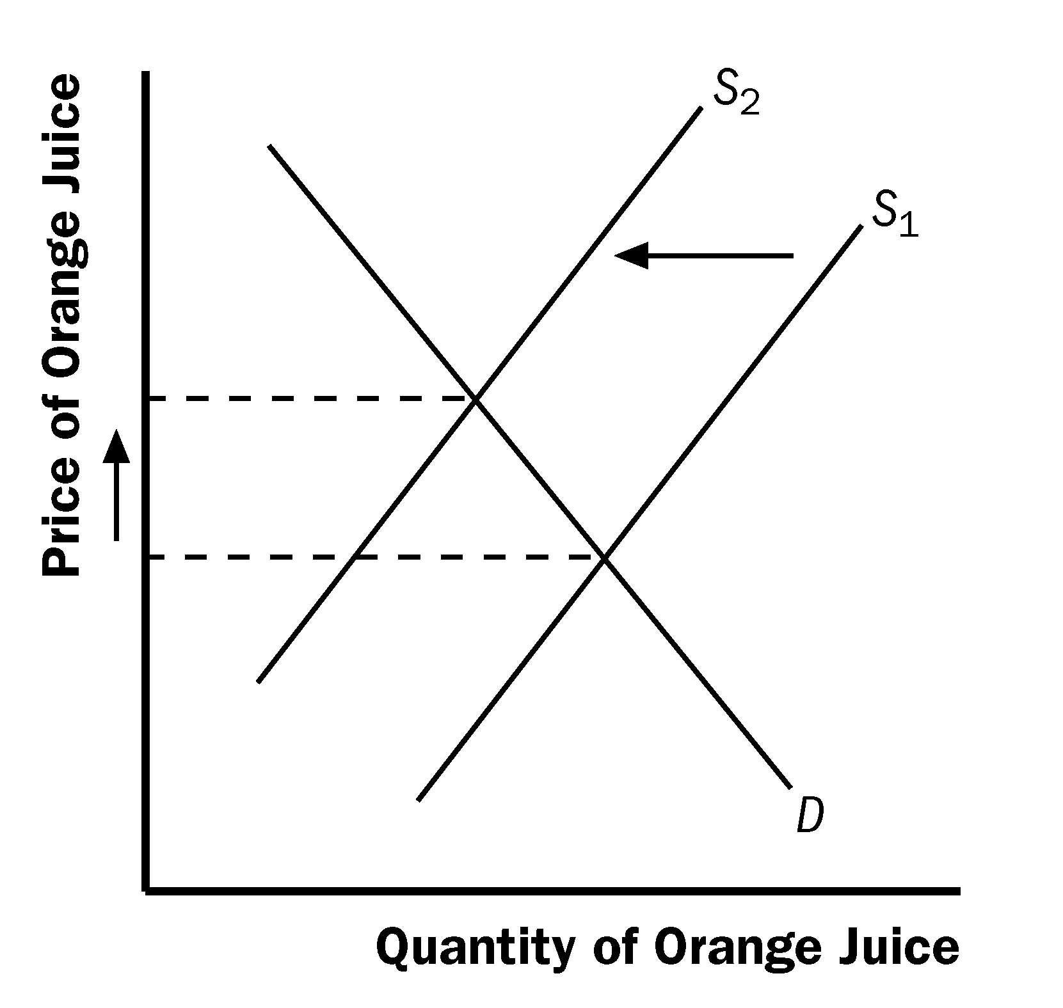

Figure 6

b. People often travel to the Caribbean from New England to escape cold weather, so the demand for Caribbean hotel rooms is high in the winter. In the summer, fewer people travel to the Caribbean, because northern climates are more pleasant. The result, as shown in Figure 7, is a shift to the left in the demand curve. The equilibrium price of Caribbean hotel rooms is thus lower in the summer than in the winter, as the figure shows.

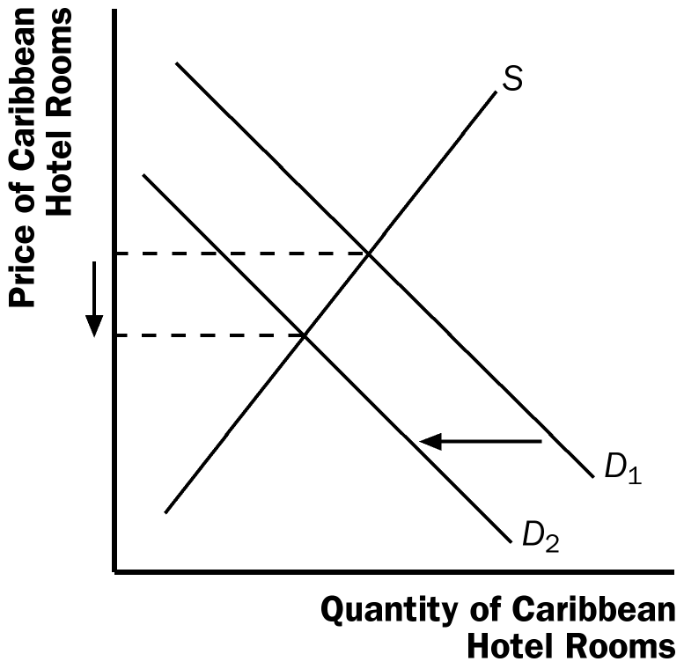

Figure 7

c. When a war breaks out in the Middle East, many markets are affected. Because a large proportion of oil production takes place there, the war disrupts oil supplies, shifting the supply curve for gasoline to the left, as shown in Figure 8. The result is a rise in the equilibrium price of gasoline. With a higher price for gasoline, the cost of operating a gas-guzzling automobile like a Cadillac will increase. As a result, the demand for used Cadillacs will decline, as people in the market for cars will not find Cadillacs as attractive. In addition, some people who already own Cadillacs will try to sell them. The result is that the demand curve for used Cadillacs shifts to the left, while the supply curve shifts to the right, as shown in Figure 9. The result is a decline in the equilibrium price of used Cadillacs.

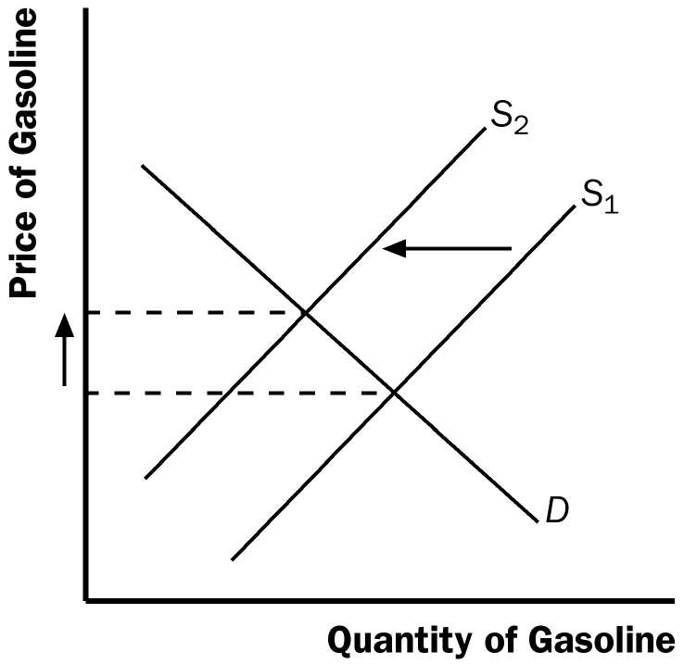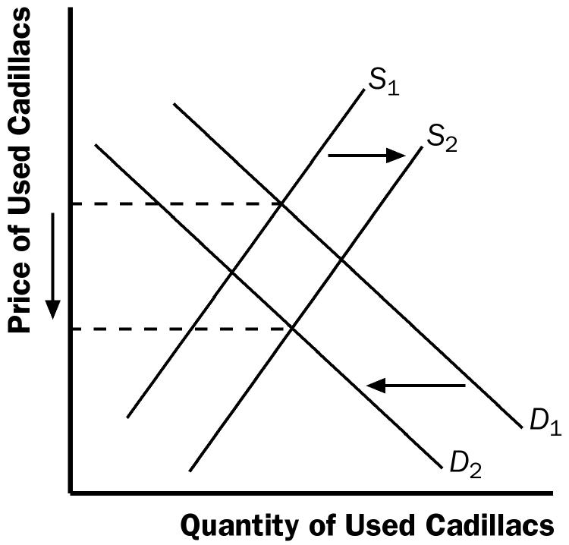

Figure 8 Figure 9

2. The statement is false. As Figure 10 shows, in equilibrium the increase in demand for notebooks results in an increased quantity demanded and the quantity supplied.

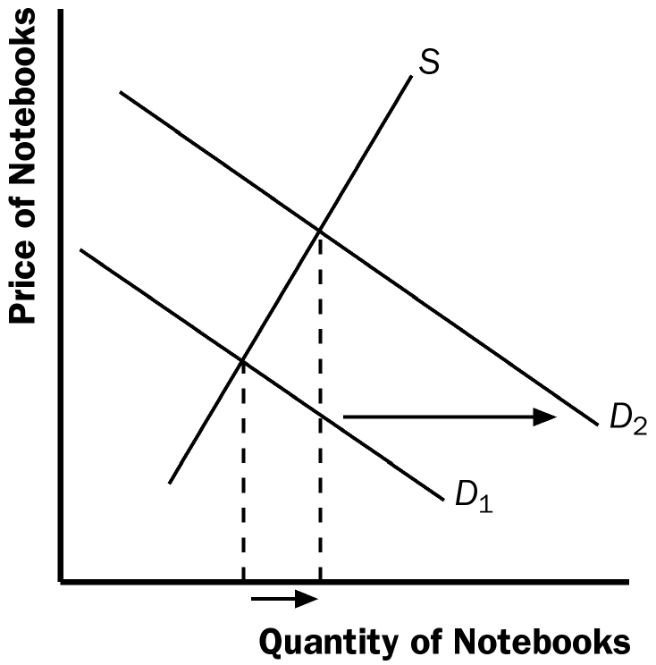

Figure 10 Figure 11

3. a. If people decide to have more children, they will want larger vehicles for hauling their kids around, so the demand for minivans will increase. Supply will not be affected. The result is a rise in both the price and the quantity sold, as Figure 12 shows.

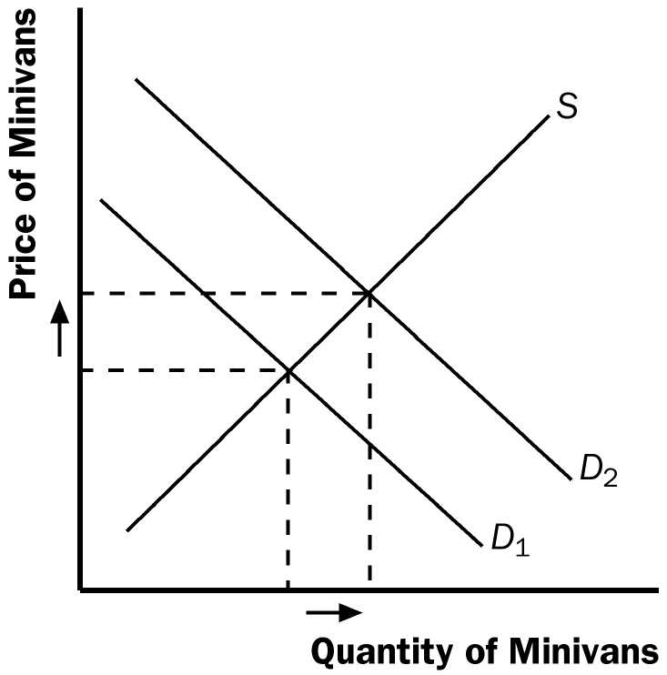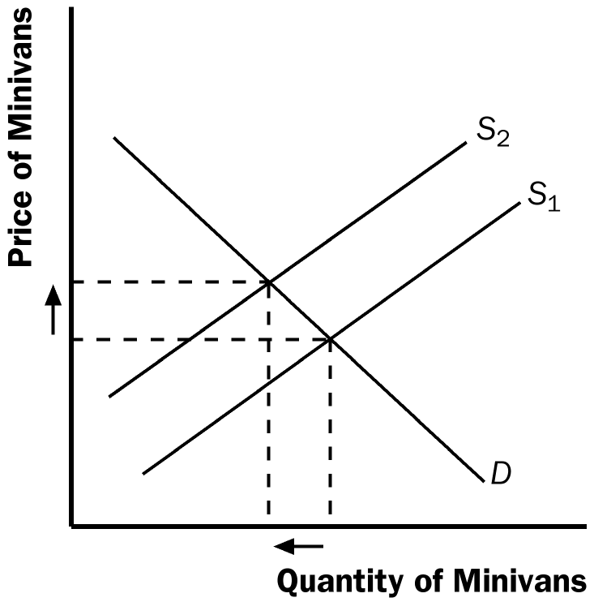

Figure 12 Figure 13

b. If a strike by steelworkers raises steel prices, the cost of producing a minivan rises and the supply of minivans decreases. Demand will not be affected. The result is a rise in the price of minivans and a decline in the quantity sold, as Figure 13 shows.
c. The development of new automated machinery for the production of minivans is an improvement in technology. This reduction in firms' costs will result in an increase in supply. Demand is not affected. The result is a decline in the price of minivans and an increase in the quantity sold, as Figure 14 shows.

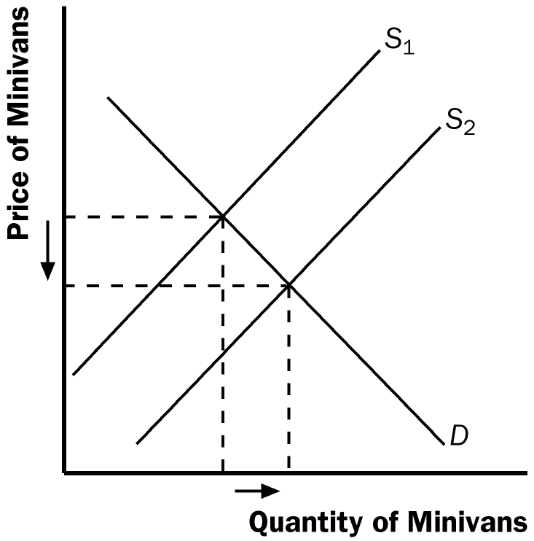

Figure 14

d. The rise in the price of sport utility vehicles affects minivan demand because sport utility vehicles are substitutes for minivans. The result is an increase in demand for minivans. Supply is not affected. The equilibrium price and quantity of minivans both rise, as Figure 12 shows.

e. The reduction in peoples' wealth caused by a stock-market crash reduces their income, leading to a reduction in the demand for minivans, because minivans are likely a normal good. Supply is not affected. As a result, both the equilibrium price and the equilibrium quantity decline, as Figure 15 shows.

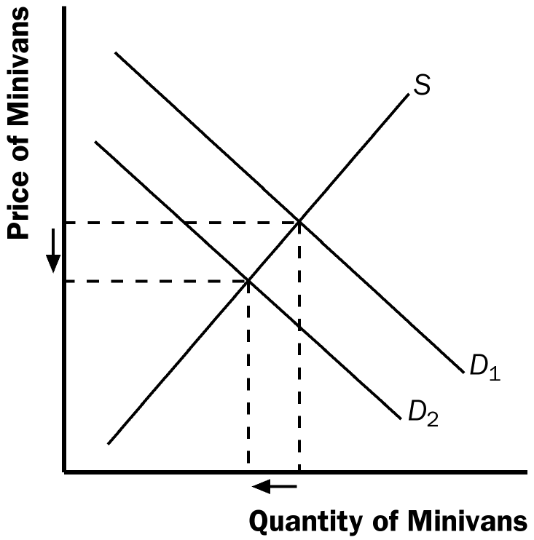

Figure 15

4. a. DVDs and TV screens are likely to be complements because you cannot watch a DVD without a television. DVDs and movie tickets are likely to be substitutes because a movie can be watched at a theater or at home. TV screens and movie tickets are likely to be substitutes for the same reason.

b. The technological improvement would reduce the cost of producing a TV screen, shifting the supply curve to the right. The demand curve would not be affected. The result is that the equilibrium price will fall, while the equilibrium quantity will rise. This is shown in Figure 16.

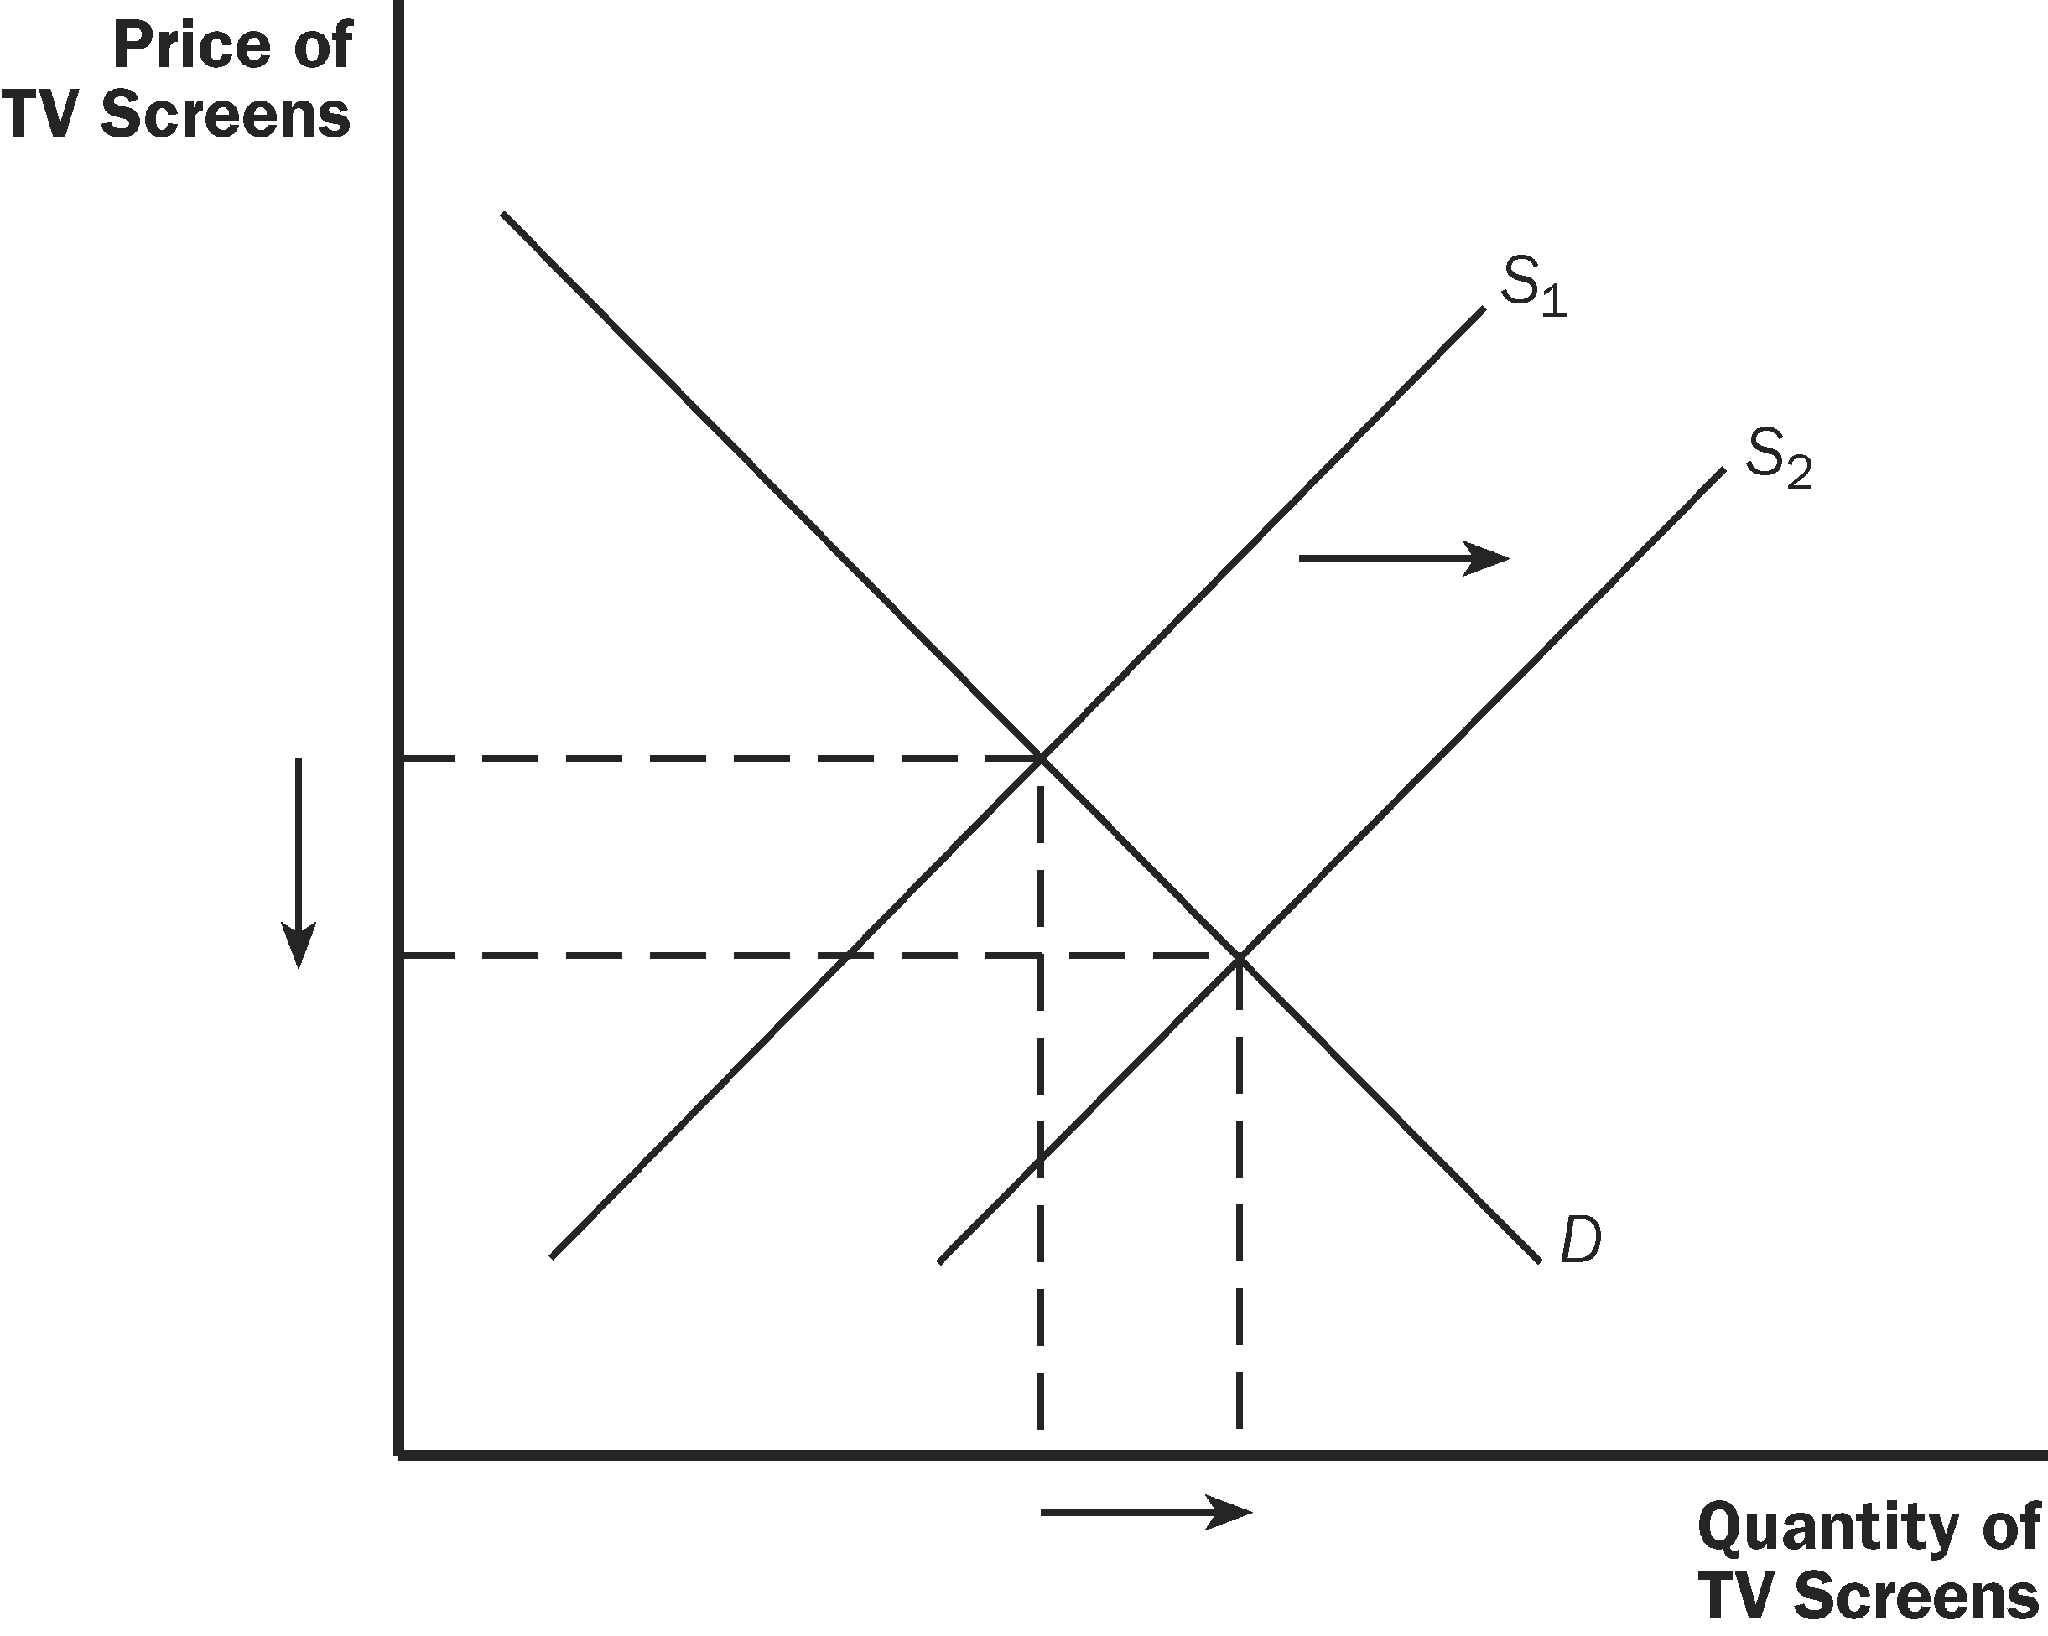

Figure 16
c. The reduction in the price of TV screens would lead to an increase in the demand for DVDs because TV screens and DVDs are complements. The effect of this increase in the demand for DVDs is an increase in both the equilibrium price and quantity, as shown in Figure 17.
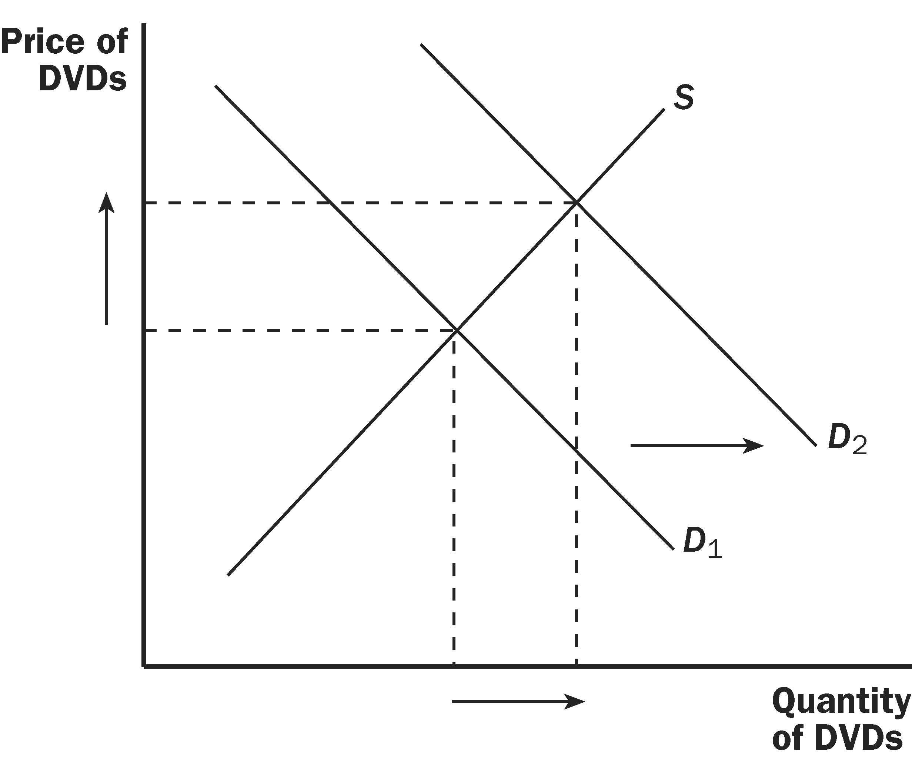
Figure 17

The reduction in the price of TV screens would cause a decline in the demand for movie tickets because TV screens and movie tickets are substitute goods. The decline in the demand for movie tickets would lead to a decline in the equilibrium price and quantity sold. This is shown in Figure 18.

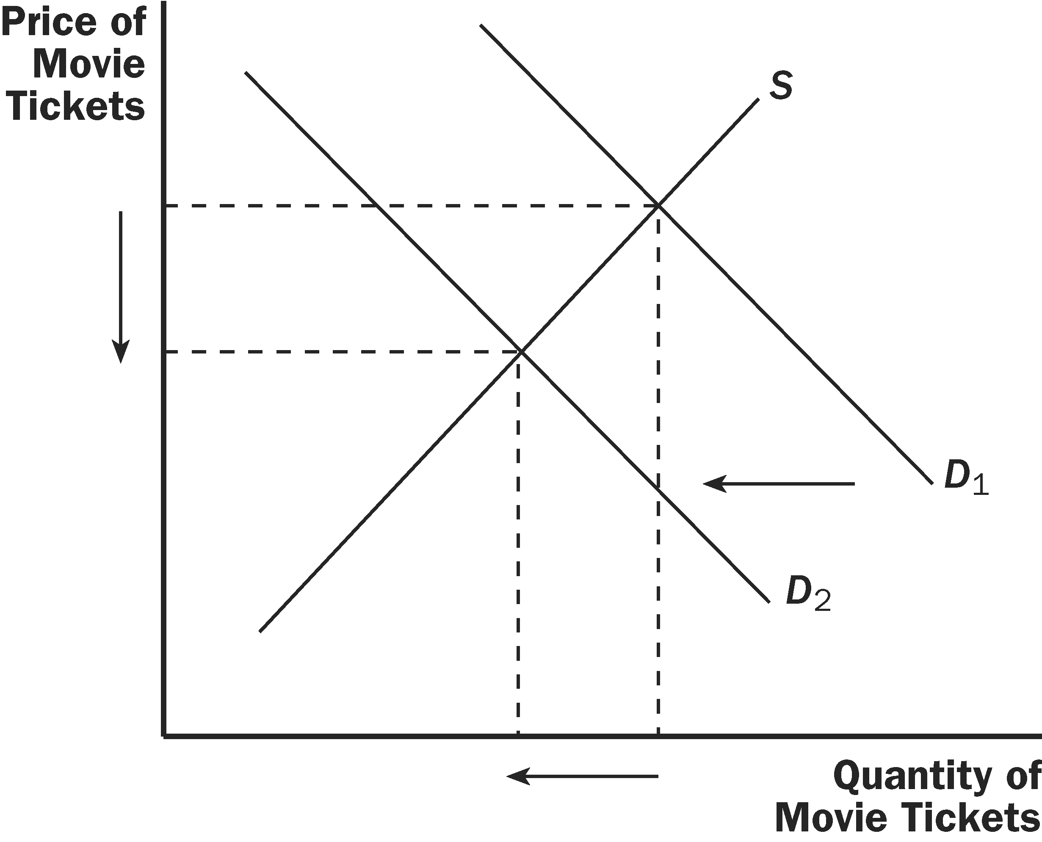
Figure 18

5. Technological advances that reduce the cost of producing computer chips represent a decline in an input price for producing a computer. The result is a shift to the right in the supply of computers, as shown in Figure 19. The equilibrium price falls and the equilibrium quantity rises, as the figure shows.

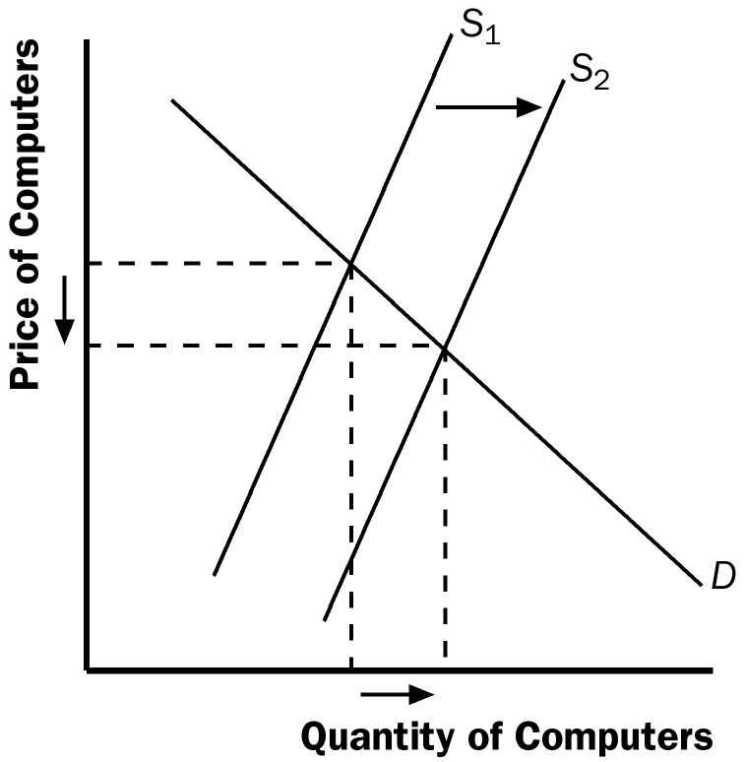

Figure 19

Because computer software is a complement to computers, the lower equilibrium price of computers increases the demand for software. As Figure 20 shows, the result is a rise in both the equilibrium price and quantity of software.

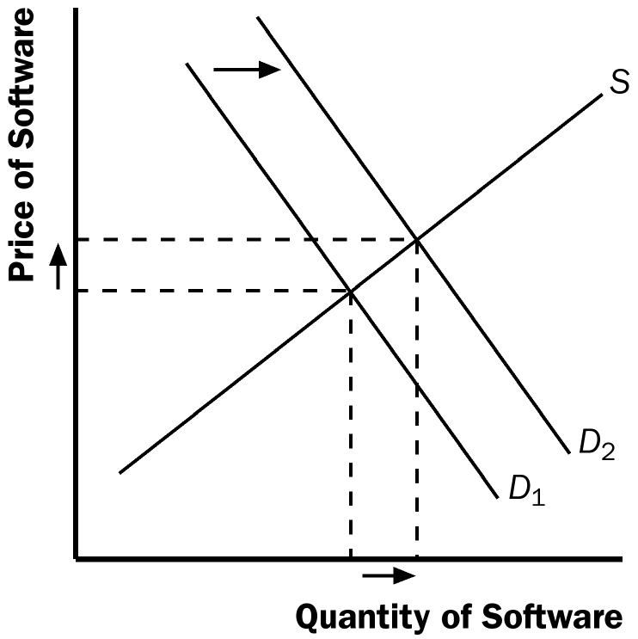

Figure 20

Because typewriters are substitutes for computers, the lower equilibrium price of computers reduces the demand for typewriters. As Figure 21 shows, the result is a decline in both the equilibrium price and quantity of typewriters.

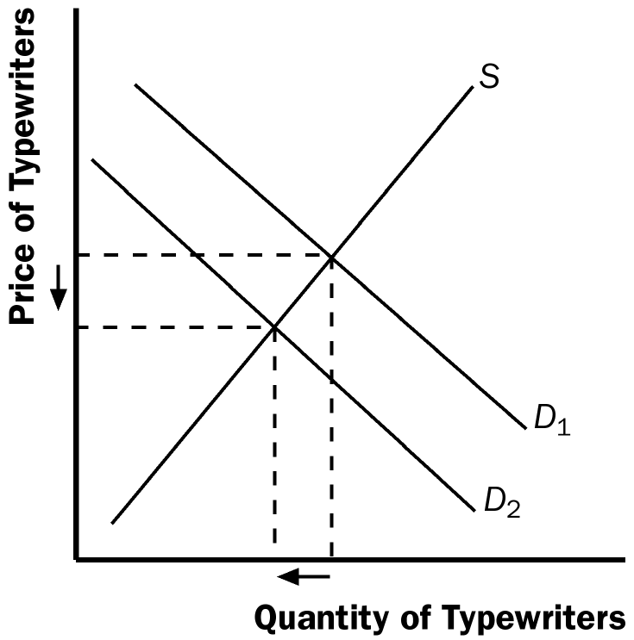

Figure 21

6. a. When a hurricane in South Carolina damages the cotton crop, it raises input prices for producing sweatshirts. As a result, the supply of sweatshirts shifts to the left, as shown in Figure 22. The new equilibrium price is higher and the new equilibrium quantity of sweatshirts is lower.

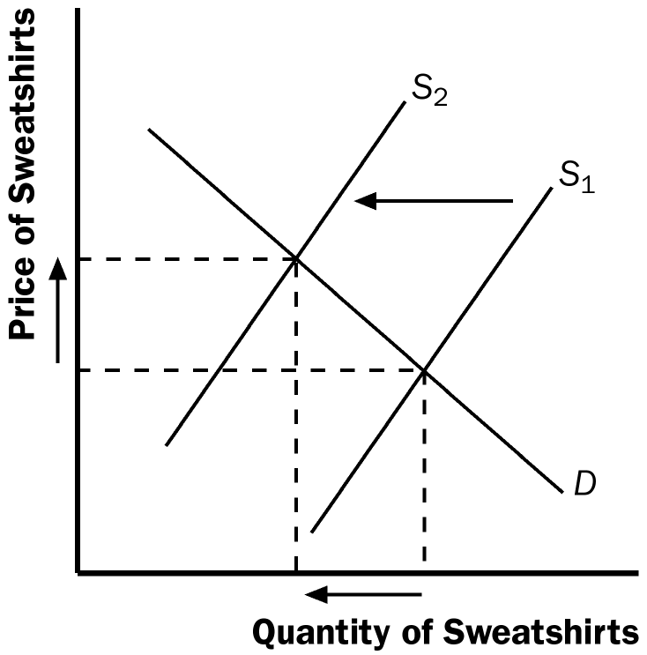

Figure 22

b. A decline in the price of leather jackets leads more people to buy leather jackets, reducing the demand for sweatshirts. The result, shown in Figure 23, is a decline in both the equilibrium price and quantity of sweatshirts.

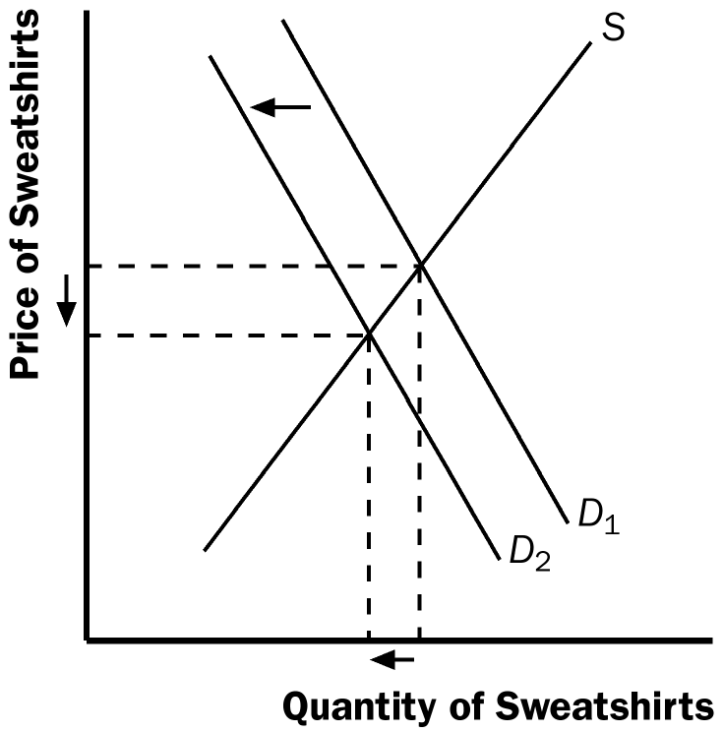

Figure 23

c. The effects of colleges requiring students to engage in morning exercise in appropriate attire raises the demand for sweatshirts, as shown in Figure 24. The result is an increase in both the equilibrium price and quantity of sweatshirts.

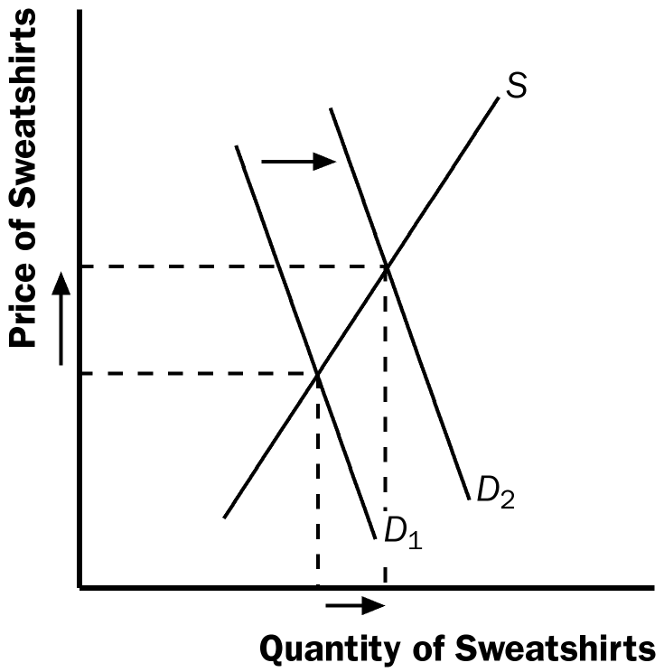

Figure 24

d. The invention of new knitting machines increases the supply of sweatshirts. As Figure 25 shows, the result is a reduction in the equilibrium price and an increase in the equilibrium quantity of sweatshirts.

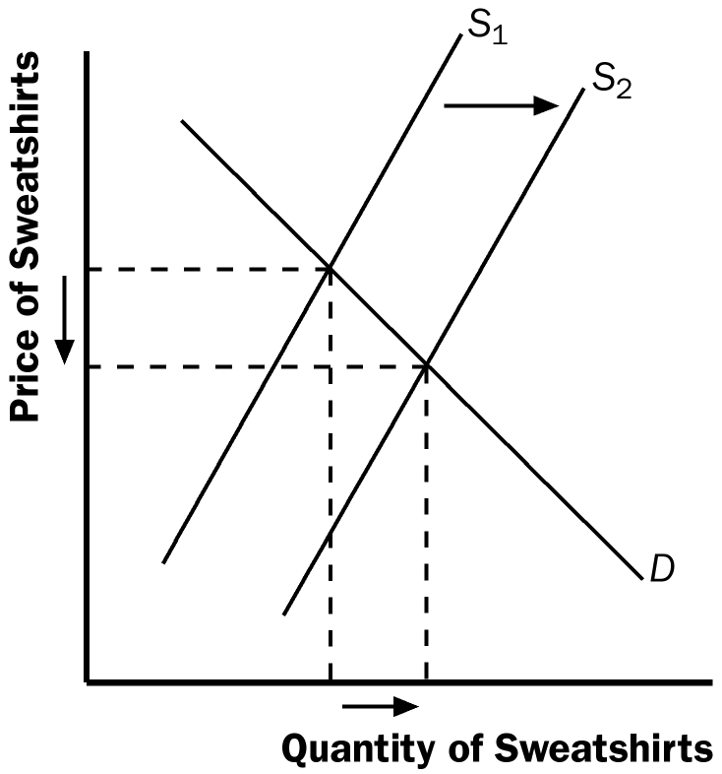

Figure 25

7. Ketchup is a complement for hot dogs. Therefore, when the price of hot dogs rises, the quantity demanded of hot dogs falls and this lowers the demand for ketchup. The end result is that both the equilibrium price and quantity of ketchup fall. Because the quantity of ketchup falls, the demand for tomatoes by ketchup producers falls, so the equilibrium price and quantity of tomatoes fall. When the price of tomatoes falls, producers of tomato juice face lower input prices, so the supply curve for tomato juice shifts out, causing the price of tomato juice to fall and the quantity of tomato juice to rise. The fall in the price of tomato juice causes people to substitute tomato juice for orange juice, so the demand for orange juice declines, causing the price and quantity of orange juice to fall. Now you can see clearly why a rise in the price of hot dogs leads to a fall in the price of orange juice!

8. a. Quantity supplied equals quantity demanded at a price of $6 and quantity of 81 pizzas (Figure 30).

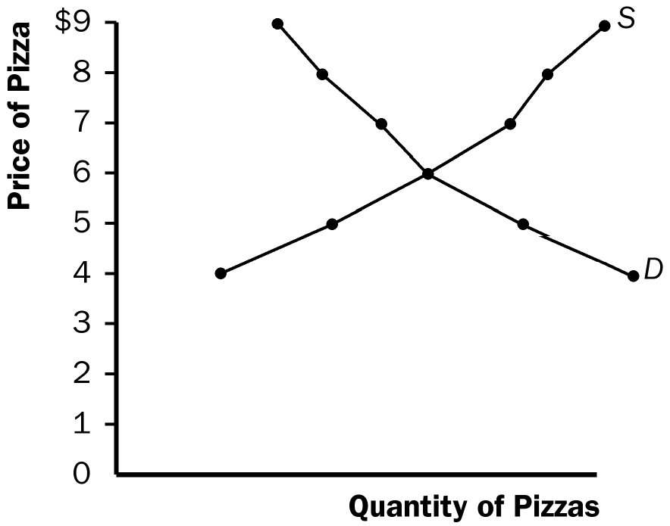

Figure 30

b. If the price were above $6, quantity supplied would exceed quantity demanded, so suppliers would reduce the price to gain sales.

c. If the price were below $6, quantity demanded would exceed quantity supplied, so suppliers could raise the price without losing sales. In both cases, the price would continue to adjust until it reached $6, the only price at which there is neither a surplus nor a shortage.

9. The news of the increased health benefits from consuming oranges will increase the demand for oranges, increasing both the equilibrium price and quantity. If farmers use a new fertilizer that makes orange trees more productive, the supply of oranges will increase, leading to a fall in the equilibrium price but a rise in the equilibrium quantity. If both occur at the same time, the equilibrium quantity will definitely rise, but the effect on equilibrium price will be ambiguous.

10. a. Because flour is an ingredient in bagels, a decline in the price of flour would shift the supply curve for bagels to the right. The result, shown in Figure 31, would be a fall in the price of bagels and a rise in the equilibrium quantity of bagels.

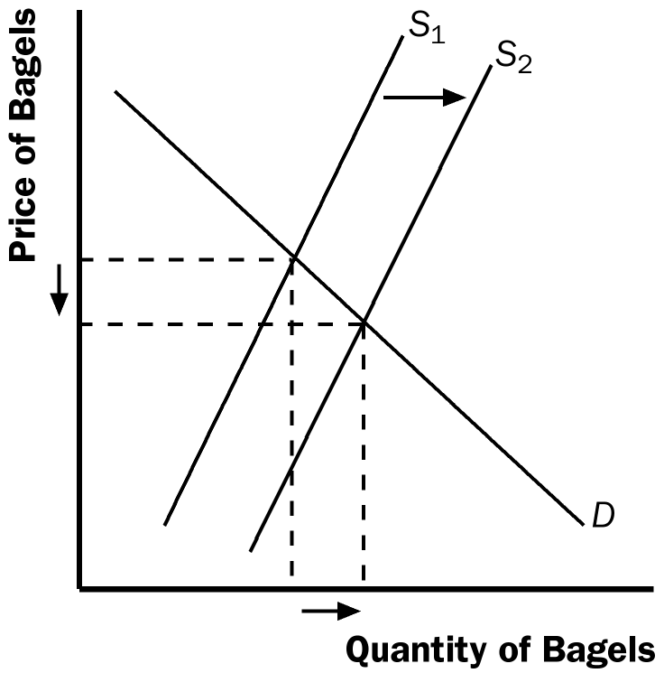

Figure 31

Because cream cheese is a complement to bagels, the fall in the equilibrium price of bagels increases the demand for cream cheese, as shown in Figure 32. The result is a rise in both the equilibrium price and quantity of cream cheese. So, a fall in the price of flour indeed raises both the equilibrium price of cream cheese and the equilibrium quantity of bagels.

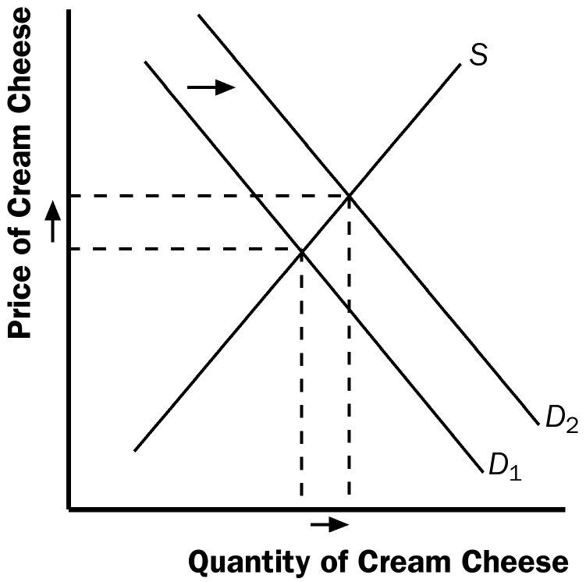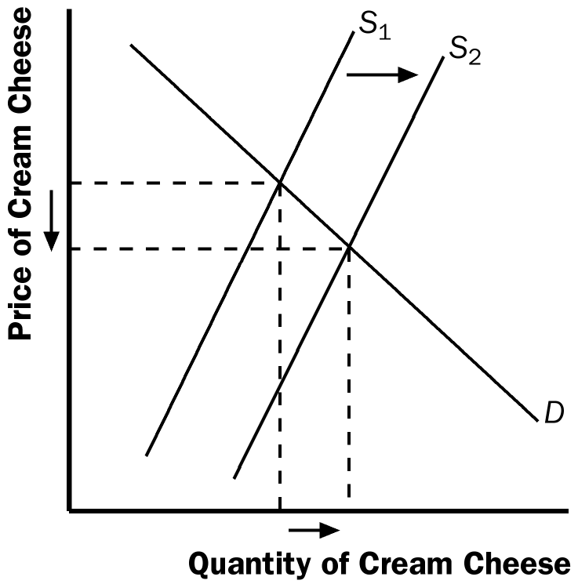

Figure 32 Figure 33

What happens if the price of milk falls? Because milk is an ingredient in cream cheese, the fall in the price of milk leads to an increase in the supply of cream cheese. This leads to a decrease in the price of cream cheese (Figure 33), rather than a rise in the price of cream cheese. So a fall in the price of milk could not have been responsible for the pattern observed.

b. In part (a), we found that a fall in the price of flour led to a rise in the price of cream cheese and a rise in the equilibrium quantity of bagels. If the price of flour rose, the opposite would be true; it would lead to a fall in the price of cream cheese and a fall in the equilibrium quantity of bagels. Because the question says the equilibrium price of cream cheese has risen, it could not have been caused by a rise in the price of flour.

What happens if the price of milk rises? From part (a), we found that a fall in the price of milk caused a decline in the price of cream cheese, so a rise in the price of milk would cause a rise in the price of cream cheese. Because bagels and cream cheese are complements, the rise in the price of cream cheese would reduce the demand for bagels, as Figure 34 shows. The result is a decline in the equilibrium quantity of bagels. So a rise in the price of milk does cause both a rise in the price of cream cheese and a decline in the equilibrium quantity of bagels.

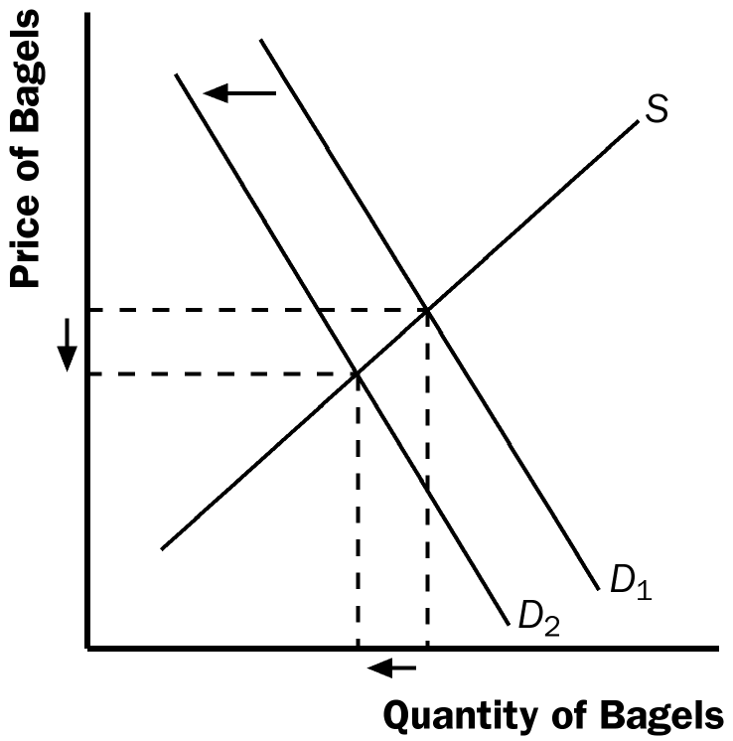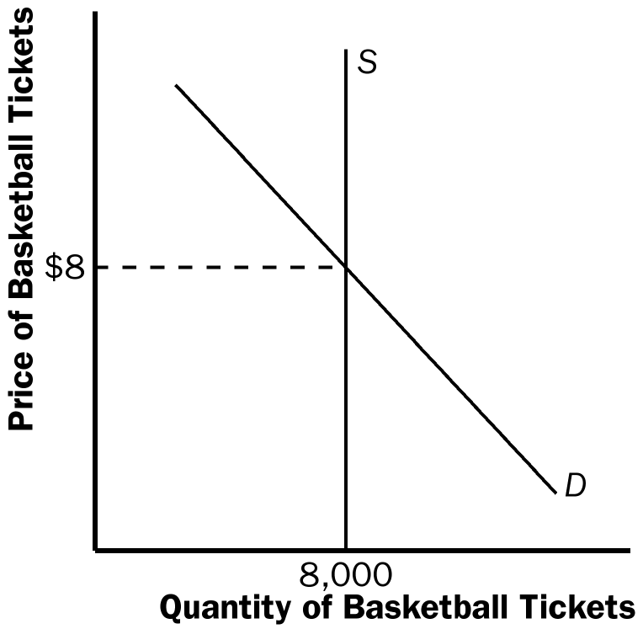

Figure 34 Figure 35

11. a. As Figure 35 shows, the supply curve is vertical. The constant quantity supplied makes sense because the basketball arena has a fixed number of seats at any price.

b. Quantity supplied equals quantity demanded at a price of $8. The equilibrium quantity is 8,000 tickets.

c.
Price | Quantity Demanded | Quantity Supplied
$4 | 14,000 | 8,000
$8 | 11,000 | 8,000
$12 | 8,000 | 8,000
$16 | 5,000 | 8,000
$20 | 2,000 | 8,000

The new equilibrium price will be $12, which equates quantity demanded to quantity supplied. The equilibrium quantity remains 8,000 tickets.

